**ECE 385**

Spring 2020

Experiment 3

Bit Serial Logic Processor

Arkajit Dutta, Anand Sunderrajan

Section ABD – Tuesday 6 pm

Nicholas Cebry, Wenjie Pan

**Introduction**

In this lab, we had to design a bit-serial logic processor which would take inputs from 2 4-bit shift registers – A, B – and perform 8 different functions with 4 different ways of routing the results of the operation for each function. The 8 functions defined by F2, F1, F0 included AND, NAND, OR, NOR, XOR, XNOR, 1111 and 0000. Depending on the sequence of the F2, F1, F0 the logic processor would choose the function to operate on the bits of A and B, resulting in the output F. Furthermore, the logic processor, depending on the values of R0 and R1, can switch the outputs of A and B, display F for either A or B, or do nothing.

Pre-Lab Questions

1. Describe the simplest (two-input one-output) circuit that can optionally invert a signal (i.e., one input determines if the output is equal to the other input or equal to the other input inverted). Sketch your circuit.

The simplest two-input one-output circuit that can optionally invert a signal is an XOR logic circuit. The following is the truth table for an XOR gate.

|  |  |  |
| --- | --- | --- |
| **A** | **B** | **XOR(A,B)** |
| 0 | 0 | 0 |
| 0 | 1 | 1 |
| 1 | 0 | 1 |
| 1 | 1 | 0 |

If we select A to the be the input that determines the output depending on input B, we observe that whenever A is low (0), the output of the logic circuit is the input B (0 – when B is 0 and 1 when B is 1). When A is high (1), the output is B inverted (0 – when B is 1 and 1 when B is 0).

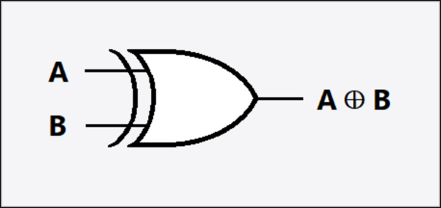

Fig : XOR Gate

1. Explain how a modular design such as that presented above improves testability and cuts down development time.

Having a modular design helps us identify bugs by testing the output and input of each pin and assessing if that is the expected value. It can also help determine if a chip is functioning properly or faulty, which can save development time by using another chip instead of re-wiring the circuit.

**Operation of Logic Processor**

The logic processor in this lab comprises of the Computation Unit and Routing Unit. The Computation Unit performs a set of functions, defined by its bit sequence of F2, F1, F0, on the inputs A and B which leads to the Routing Unit. The Routing Unit will decide what to store in A and B depending on the bit sequence of R1 and R0.

We input bits into A and B by using the switches D0 – D3 ( SA2 – SA5) and the bits are loaded into A and B by the switches LoadA and LoadB ( SB1 and SB2) non-synchronously. Once the bits are loaded into registers A and B, we proceed with the implementation of Computation Unit to determine F. F (f(A,B)) is the Computation Unit Output defined by the switches F2 – F0 ( SB3 – SB5) and the list of functions defined by the Computation Output is explained in the table below.

**Function Selection Table**

|  |  |  |  |
| --- | --- | --- | --- |
| **Function Selection Inputs** | | | **Computation Unit Output** |
| **F2** | **F1** | **F0** | **f(A,B)** |
| 0 | 0 | 0 | A AND B |
| 0 | 0 | 1 | A OR B |
| 0 | 1 | 0 | A XOR B |
| 0 | 1 | 1 | 1111 |
| 1 | 0 | 0 | A NAND B |
| 1 | 0 | 1 | A NOR B |
| 1 | 1 | 0 | A XNOR B |
| 1 | 1 | 1 | 0000 |

Once, the value of F has been calculated by the Computation Unit, A, B, and F go into the Routing Unit. The Routing Unit will determine what value to store in the registers A and B, depending on the value of R1 and R0. As explained in the table below, if the input is 00, the value of A and B will be unchanged as A* and B* will have the values of A and B, respectively. For 01, the value of A remains unchanged but B stores the value of F (the output of the computation unit). For the inputs 10, the value of B remains unchanged but A stores the value F.

For input 11, the inputs and outputs are swapped in registers A and B – B stores the value of A and A stores the value of B.

**Router Selection Table**

|  |  |  |  |
| --- | --- | --- | --- |
| **Router Selection** | | **Router Output** | |
| **R1** | **R0** | **A\*** | **B\*** |
| 0 | 0 | A | B |
| 0 | 1 | A | F |
| 1 | 0 | F | B |
| 1 | 1 | B | A |

Once, the switches F2-F0 and R1 and R0 are selected by the user we flip the Execute Switch (SA1) to 1. This will enable the circuit to perform the Computation and Routing Units.

**Written Description**

**Control Unit:**

**Register Unit:**

**Computation Unit:**

**Routing Unit:**

**Block Diagram**

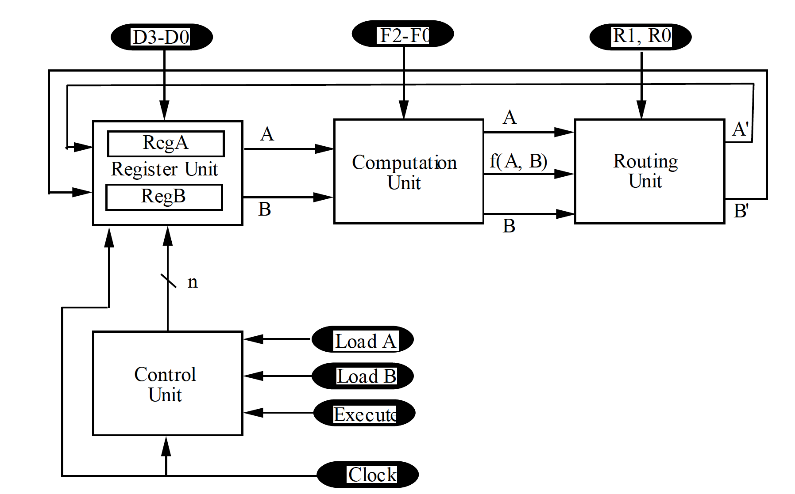

**State Machine**

**Control State Machine using the Mealy State Machine**

|  |  |  |  |  |  |  |  |
| --- | --- | --- | --- | --- | --- | --- | --- |
| Execute Q C1 C0 | | | | Reg.Shift.  (S) Q* C1* C0* | | | |
| 0 | 0 | 0 | 0 | 0 | 0 | 0 | 0 |
| 0 | 0 | 0 | 1 | x | x | x | X |
| 0 | 0 | 1 | 0 | x | x | x | x |
| 0 | 0 | 1 | 1 | x | x | x | x |
| 0 | 1 | 0 | 0 | 0 | 0 | 0 | 0 |
| 0 | 1 | 0 | 1 | 1 | 1 | 1 | 0 |
| 0 | 1 | 1 | 0 | 1 | 1 | 1 | 1 |
| 0 | 1 | 1 | 1 | 1 | 1 | 0 | 0 |
| 1 | 0 | 0 | 0 | 1 | 1 | 0 | 1 |
| 1 | 0 | 0 | 1 | x | x | x | X |
| 1 | 0 | 1 | 0 | x | x | x | X |
| 1 | 0 | 1 | 1 | x | x | x | X |
| 1 | 1 | 0 | 0 | 0 | 1 | 0 | 0 |
| 1 | 1 | 0 | 1 | 1 | 1 | 1 | 0 |
| 1 | 1 | 1 | 0 | 1 | 1 | 1 | 1 |
| 1 | 1 | 1 | 1 | 1 | 1 | 0 | 0 |

**State Diagram**

We used Mealy Machine in this lab (shown in Figure below) as it used fewer states than a Moore Machine and is easier to implement. The first 2 bits represent the counter (C1C0), the next bit represents the Execute bit and the last bit represents the shifting state.

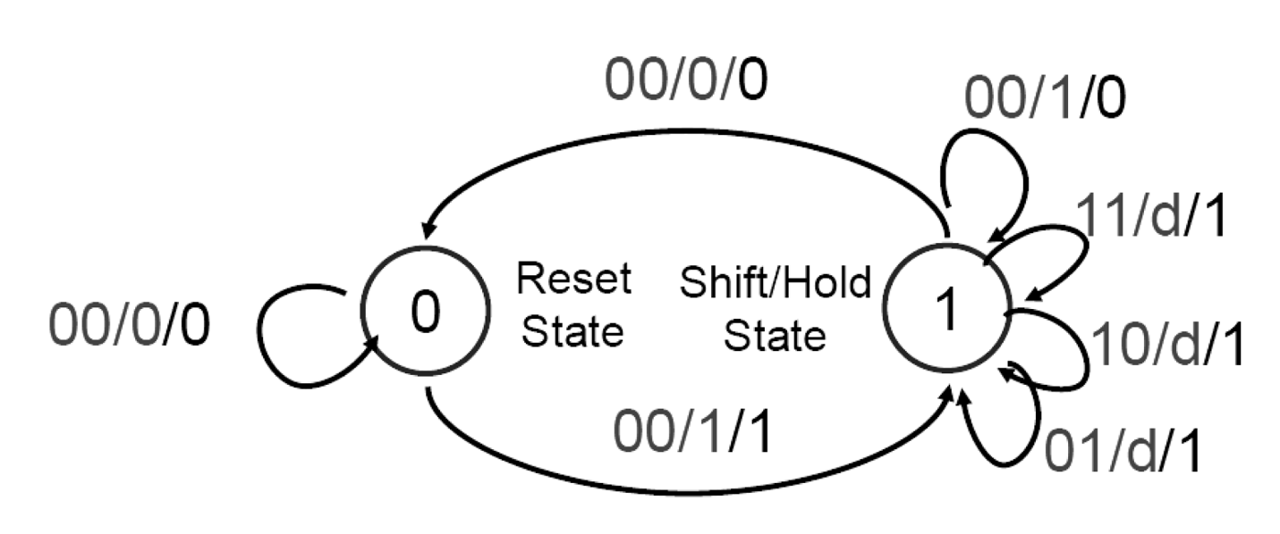

Fig: Mealy Machine

**Component Layout**



Fig : Component Layout

**Conclusion**

In hindsight, this lab went relatively smoothly. We had difficulty understanding how to integrate the routing unit in the logic diagram into the design, but after thoroughly going through the Mealy Machine and the provided Control State Machine table in the lab manual we figured out the steps required to design the circuit. Circuitry went smoothly, except trivial wiring issues like connecting Ground to low. This lab was extremely informative and helped us understand how to implement a complex logic circuit by TTL. We learnt the concept of state machine and routing units, which will likely help us design more efficiently in future labs.